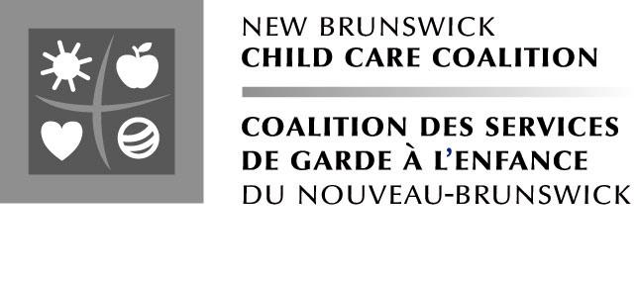

Membership Form

Yes! I want to join the New Brunswick Child Care Coalition. I support the work of New Brunswick Child Care Coalition towards:

- Child care as the cornerstone of progressive family policies,

- The right of all children to access a child care system supported by public funds,

- A comprehensive and affordable child care system that is inclusive, quality, with well-paid and trained staff and with the expansion of services in the non-profit sector,

- A range of child care services for young and school aged children.

Name: __________________________________________

Mailing Address: __________________________________________

__________________________________________

Fax: __________________________________________

Phone : __________________________________________

Email: __________________________________________

Please mail this form to:

New Brunswick Child Care Coalition
51 Williams Street
Moncton, New Brunswick E1C 2G6

or email it to: nbccc.csgnb@rogers.com

